
Khwaja Yunus Ali University

Lab Report -05

Name of the Department: Computer Science and Engineering
Course Code: CSE 0713-1105
Course Title: Electrical Circuit Lab
Experiment No.: 05
Name of the Experiment: Verification of Nodal Analysis Using Hardware and Digital Simulation
Date of Experiment : 16-03-2025
Date of Submission : 23-03-2025

Instructor Signature & Date

Submitted by – |  | Submitted to –

Name: Md Sojib Ahmed
ID Number: 06224205101006
Batch No: 18th
Semester: 1st Year 2nd Semester
Khwaja Yunus Ali University
Name: Sakil Ahammed
Lecturer
Department of EEE
Khwaja Yunus Ali University

Name of the Experiment:
Verification of Nodal Analysis Using Hardware and Digital Simulation
Objectives
To verify Nodal Analysis using hardware and digital simulation.
Theory:
Nodal Analysis is a method used to determine the voltage at different nodes in an electrical circuit using Kirchhoff’s Current Law (KCL). It helps simplify circuit analysis by using node voltages instead of current equations.
Circuit Diagram:
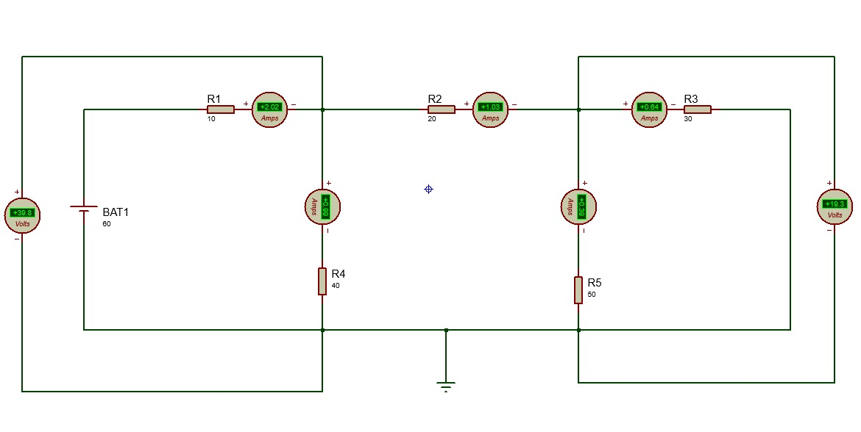
Fig . (1) Nodal Analysi

Apparatus:
• Software used: Proteus 8 Professional
• Voltmeter
• Resistor
• Power Supply
• Connecting Wires

Working Procedure:
- Constructed the circuit as per the diagram in Proteus 8 Professional.
- Identified the principal nodes and selected a reference (ground) node.
- Applied Kirchhoff’s Current Law (KCL) to each non-reference node.
- Solved the equations to determine node voltages.
- Measured the voltage at each node using simulation.
- Compared the theoretical and simulated values.
Calculations:
Given Values:
- Voltage Source (V_s): 60V
- Resistor:
$$R_{1}=10Ω,R_{2}=20Ω,R_{3}=30Ω,R_{4}=40Ω,R_{5}=50Ω$$

At Node $1\left(V_{1}\right)$ :
$$\frac{V_{1}-V_{s}}{R_{1}}+\frac{V_{1}}{R_{4}}+\frac{V_{1}-V_{2}}{R_{2}}=0$$
Substituting values:
$$\frac{V_{1}-60}{10}+\frac{V_{1}}{40}+\frac{V_{1}-V_{2}}{20}=0$$
Multiply by 40 (LCM):
$$4\left(V_{1}-60\right)+V_{1}+2\left(V_{1}-V_{2}\right)=0⟹7V_{1}-2V_{2}=240 (\text{ Equation }1)$$
At Node $2\left(V_{2}\right)$ :
$$\frac{V_{2}-V_{1}}{R_{2}}+\frac{V_{2}}{R_{3}}+\frac{V_{2}}{R_{5}}=0$$
Substituting values:
$$\frac{V_{2}-V_{1}}{20}+\frac{V_{2}}{30}+\frac{V_{2}}{50}=0$$

Multiply by 300 (LCM):
$$15\left(V_{2}-V_{1}\right)+10V_{2}+6V_{2}=0⟹-15V_{1}+31V_{2}=0 (\text{ Equation }2)$$

Solving Equations:
From Equation 2:
$$V_{1}=\frac{31}{15}V_{2}$$
Substitute $V_{1}$ into Equation 1:

$$7\left(\frac{31}{15}V_{2}\right)-2V_{2}=240⟹\frac{217V_{2}}{15}-2V_{2}=240⟹\frac{187V_{2}}{15}=240$$
$$\begin{matrix} & V_{2}=\frac{240×15}{187}≈19.25 V \\ & V_{1}=\frac{31}{15}×19.25≈39.8 V\end{matrix}$$

Observation Table:
SL No | Input Voltage (V) | V1 (Simulated) | V2 (Simulated) | V1 (Calculated) | V2 (Calculated)
1 | 60 | 39.8 | 19.3 | 39.8 | 19.25
2 | 55 | 36.5 | 17.5 | 36.4 | 17.4
3 | 50 | 33.2 | 15.8 | 33.1 | 15.7
4 | 45 | 29.9 | 14.1 | 29.8 | 14.0

Result and Discussion:
• The calculated node voltages closely match the theoretical values.
• Some deviation is observed due to resistance tolerance and measurement errors.
• The experiment successfully verifies Nodal Analysis.

Conclusion:
Using Nodal Analysis, we determined the voltages at different nodes using Kirchhoff's Current Law (KCL). The experiment verified that the sum of currents at each node is zero, confirming the accuracy of Nodal Analysis.

